Quality assurance

# QA plan

## Customers identify

Industry supervisor: Mike Lance, Dr. Mike has been helping me to check my progress of my whole course plan.

Industry:

Academic supervisor: Philip Roxborogh, Dr. Philip has been helping me to check my proposal, reports and other academic work

Course supervisor: Mike Lance, Luofeng Xu

## List of goal

It has a certain goal by categories for each phase. So I have made up a plan at the beginning of the course.

The picture below is from my proposal plan diagram.

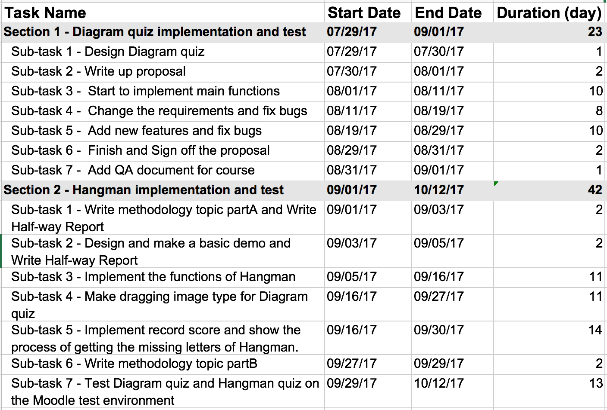

## For academic

**Proposal**: After meeting with client Anne, I took two days to get a proposal draft, after that I show it to my industry supervisor, academic supervisor and client, got feedback from them. Then modified it. I got it sign off by client on 6th Sep.

**Daily Plan:** I meet with my industry supervisor Mike on Monday every week to show him my plan of the whole week, write detail work for each hour. I study about 6 hours on this course from Monday to Friday.

**Weekly report:** I get feedback from the weekly meeting with Philip and Mike, they give me suggestions and track my process every time to lead the course work can be finish in an appropriate pattern.

**Methodology Essay:** My methodology essay topic is “Agile Project Management” I have written the part A of my methodology essay base on what I have meet with my client during the development period for the first 6 weeks.

**Halfway report:** Before I finish the Halfway report, I prepare a list of deliverable and document for proving what I have done during halfway time.

## For industry

The proposal was sign off by the client.

The functions check list was sign off in each stage

For more detail for my industry QA, please the file Quality Assurance_I.docx

# Sign off

Anne signed off the proposal;

The Daily plan sheets were checked by Mike;

The weekly work reports were checked by Philip and Mike;